Katia Mayfield

Template – use whatever cover page and title you want

**Using this Template**

When using this template there are instructions and references for each of the different sections that you must provide. You should read over each and be sure that when you modify the sections with the information that you have collected that you DO NOT leave the template information as part of your report. This information is only here to “guide” you through creating your technical document. The only portions that you can leave as is are the different section headings. With the exception of what is found on this page. This page will have to be deleted from your report in whole.

**Completing this Report**

When you have completed this technical document, you will be able to have it as part of your portfolio along with the webpages that you are creating. This is something that you can list on your resume as Classroom Experience. At the end of the semester I will provide specific content that you can copy and paste to your resume that will identify the work that you had to complete in this course.

**Creating a Table of Contents in MS Word**

The table of contents should appear on its own page after the cover page. You can create “new” sections to your table of contents by using the “Heading” styles in word. As the template is currently set up all headings that are formatted with the Heading 1 style show up in the TOC. If you add a section, or a subsection and use Heading 2 you will be able to update the TOC and it will automatically recognize the headings.

This is a link that will go into details if you are trying to set up your own:

<https://www.linkedin.com/business/learning/blog/productivity-tips/the-wicked-easy-way-to-create-a-table-of-contents-in-word>

Your section headings should be number numerically and any subheadings should be numbered with a decimal in association to that section.

**References**

I have provided a list of references based on the different links that I have shared with you on this document and also in the Resources document. You should ONLY keep the references that you actually use. Be sure you properly know how to inline cite them using IEEE format which is the accepted format for technical documents.

This link shows you how to cite inline following IEEE citation guidelines: <https://libguides.murdoch.edu.au/ieee/text>

Be sure that when you write the number into the inline citation that you are using the correct number. The references page should be the last page of your report. If you have additional references that you need to add, you can use the following webpage to help you create them: [https://www.citationmachine.net/ieee](%20https:/www.citationmachine.net/ieee) The site does run a lot of ads and it can be slow, but it does create appropriate references based on the information you enter.

Table of Contents

Website Description & Purpose 3

Stakeholders & Audience 3

Stakeholders 4

Audience 4

Sitemap 4

Wireframe 5

Live Site & Validation 5

Accessibility 5

References 5

# **Website Description & Purpose**

The description of your website will often be referred to as a meta description. This is information that can be incorporated into your actual website and will help with search engine optimization (SEO) for when someone Google’s a subject.

This link will provide you with information on how to write a meta description: <https://www.shopify.com/blog/how-to-write-meta-descriptions>

The purpose of your website allows for you to be sure that you fully understand the goal of the business (if it’s a business website) or that of your client. You cannot determine your stakeholder and your audience if you don’t fully understand the purpose of the website.

This link will provide you with guidance in identifying the purpose and goals of your website: <https://www.marketing91.com/purpose-of-a-website/>

# **Stakeholders & Audience**

Before you are able to document and discuss who your stakeholders are and who your audience is you need to be sure that you fully understand the different between the two.

The difference becomes clear simply by breaking down the terms to describe them:

Audience – the receivers of a message

Stakeholders – groups or individuals who are impacted by the decision and actions of an organization

Typically, organizations try to push out specific messages to audiences in a one-way fashion. For example, when companies send out news releases, key information is communicated to audiences. However, the organization does not expect the audience to respond or weigh in.

On the other hand, stakeholders are directly impacted by the actions of an organization and therefore hold a stake in those decisions. This includes current employees, shareholders, investors, regulators, policy-makers and more. Unlike the one-way communication that occurs with audiences, stakeholders actually do respond to and engage with messages from the organization.

## **2.1 Stakeholders**

It is important for organizations to properly manage stakeholders and effectively engage with them.

This link provides information on identifying your stakeholders. You should focus on the section titled: “What defines a key stakeholder”

<https://www.npgroup.net/blog/how-to-identify-stakeholders-for-your-website-project/>

When documenting your stakeholders, you should take these five points into account. This section of the report should not just be a few words; you should explain why the groups or individuals that you have identified are stakeholders.

## **2.2 Audience**

Your audience is actually a little bit more difficult to identify. Usually you will want to already have something in place where you are able to gather data to solidify who your audience happens to be. However, because a site does not already exist, there is no way to try and obtain demographic and access information to identify your main audience. Therefore, using some of the sources that you have been given, you need to determine what your expected audience demographic happens to be and how you will be able to optimize your audient reach.

This link provides a lot of details about audience demographics and should give you a good sense of how you can present this information.

<https://www.similarweb.com/corp/blog/research/market-research/website-demographics/>

# **Sitemap**

For this report you will need to create a sitemap. You should focus only on creating a visual sitemap through an image as we have discussed in class. However, if you one day hope to be able to be a web designer/developer you must know that sitemaps are usually created using the XML language. While we don’t have the opportunity to cover this material in this class (due to our short time together) I wanted to provide you with resources that you can look further into if you so desire.

The link below has an article which has images of a site map but also discusses an XML sitemap: <https://www.quicksprout.com/creating-website-sitemap/>

At the same time however, there are tools out there that can assist in this process. These are known as CASE Tools (Computer Aided Software Engineering Tools). So you can actually build your full site, and only after the fact obtain your sitemap. It’s not the best way to go about your design, because when you develop you could “miss” something that you may also not catch on your auto generated sitemap. Here is the link for one of these free tools: [https://www.xml-sitemaps.com/](%20https:/www.xml-sitemaps.com/)

When you create your sitemap you will be inserting an image into your document. With this you need to be sure that you include a caption and properly introduce the image in the text of the report.

This link provides some guidance associated to technical writing and has good examples. Review this link to be sure that you write your report appropriately when you use figures. You will follow the same process for other figures that you will have in the report.

<https://pressbooks.bccampus.ca/technicalwriting/chapter/figurestables/>

# **Wireframe**

The wireframe of the site will be similar to what you have created in your assignments. Each of the pages that you plan to create for this website should have a wireframe. Here you will want to use the information about Figures that is provided in the Sitemap section and displayed in the Live Site & Validation section. It is not easy to create a full website where every webpage has the same wireframe. Please be sure that you think carefully about your design and document it here.

This link provides an additional resource to creating a wireframe. Not only does it describe wireframes but it gives you examples and tools that you can use to create it:

<https://careerfoundry.com/en/blog/ux-design/how-to-create-your-first-wireframe/>

# **Live Site & Validation**

For this section it is VERY important for you to be sure that you fully understand how to document your Figures in the report because here you will have a minimum of 4, but you may have up to 2 times the number of pages that you create for the site.

For each page that you create you will have to provide a screen shot of your site live on the server, and also a screenshot showing that your HTML page validated. You may end up with something like the following. I have also centered the image and the caption on the page, this is my personal preference to do.

## **5.1 Live Site**

Figure 1 shows the homepage that Dr. Maxwell has created on the Computer Science server. Here one is able to access information about the classes that she is teaching, her weekly schedule, the research that she has conducted and information about the Math and Computer Science Club. Visitors of this site are also able to navigate to the MACS Facebook page and connect with Dr. Maxwell on linked in.

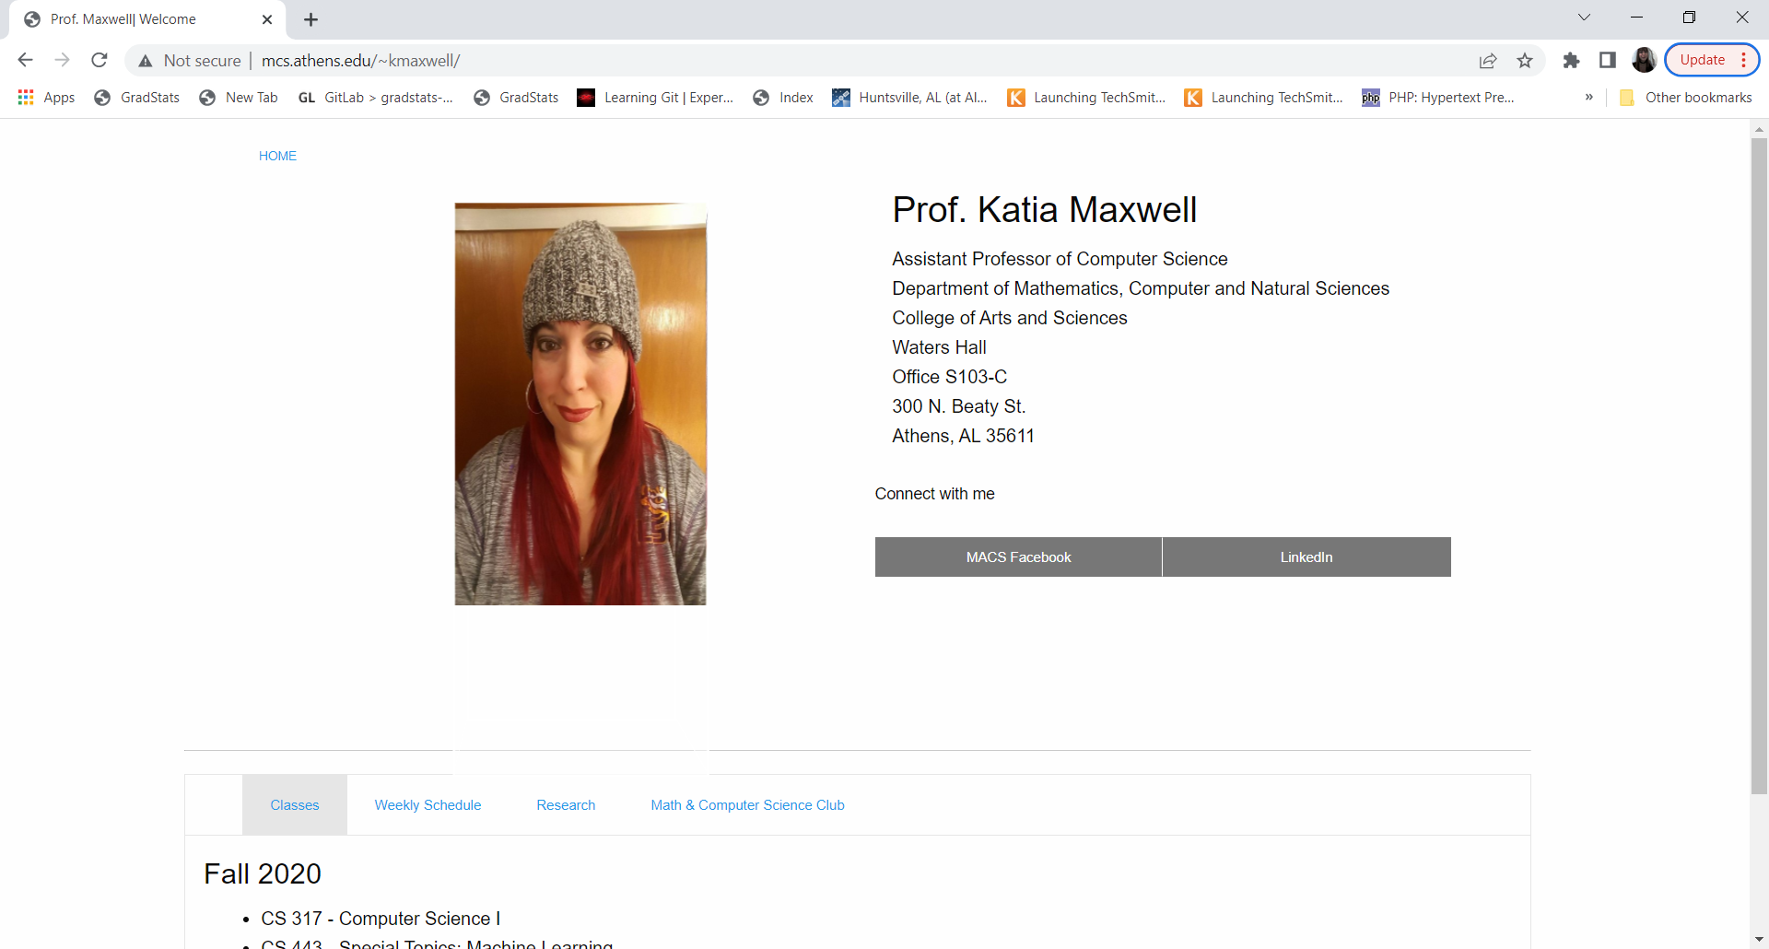

Figure Dr. Maxwell's Homepage

## **5.2 Validation**

Figure 2 shows us that Dr. Maxwell has not practiced what she preaches and it can be seen that she has several validation errors and warnings in her HTML code. These would not be difficult for her to fix as the majority are associated to just fixing her HTML elements to either include additional attributes for accessibility purposes, i.e. alternative text for images, or removing attributes that are no longer necessary with the use of HTML5 elements. Having warnings and errors as part of the HTML code results in Dr. Maxwell automatically losing 20% of her grade on this project. HTML code validation should show no errors or warnings, as shown in Figure 3.

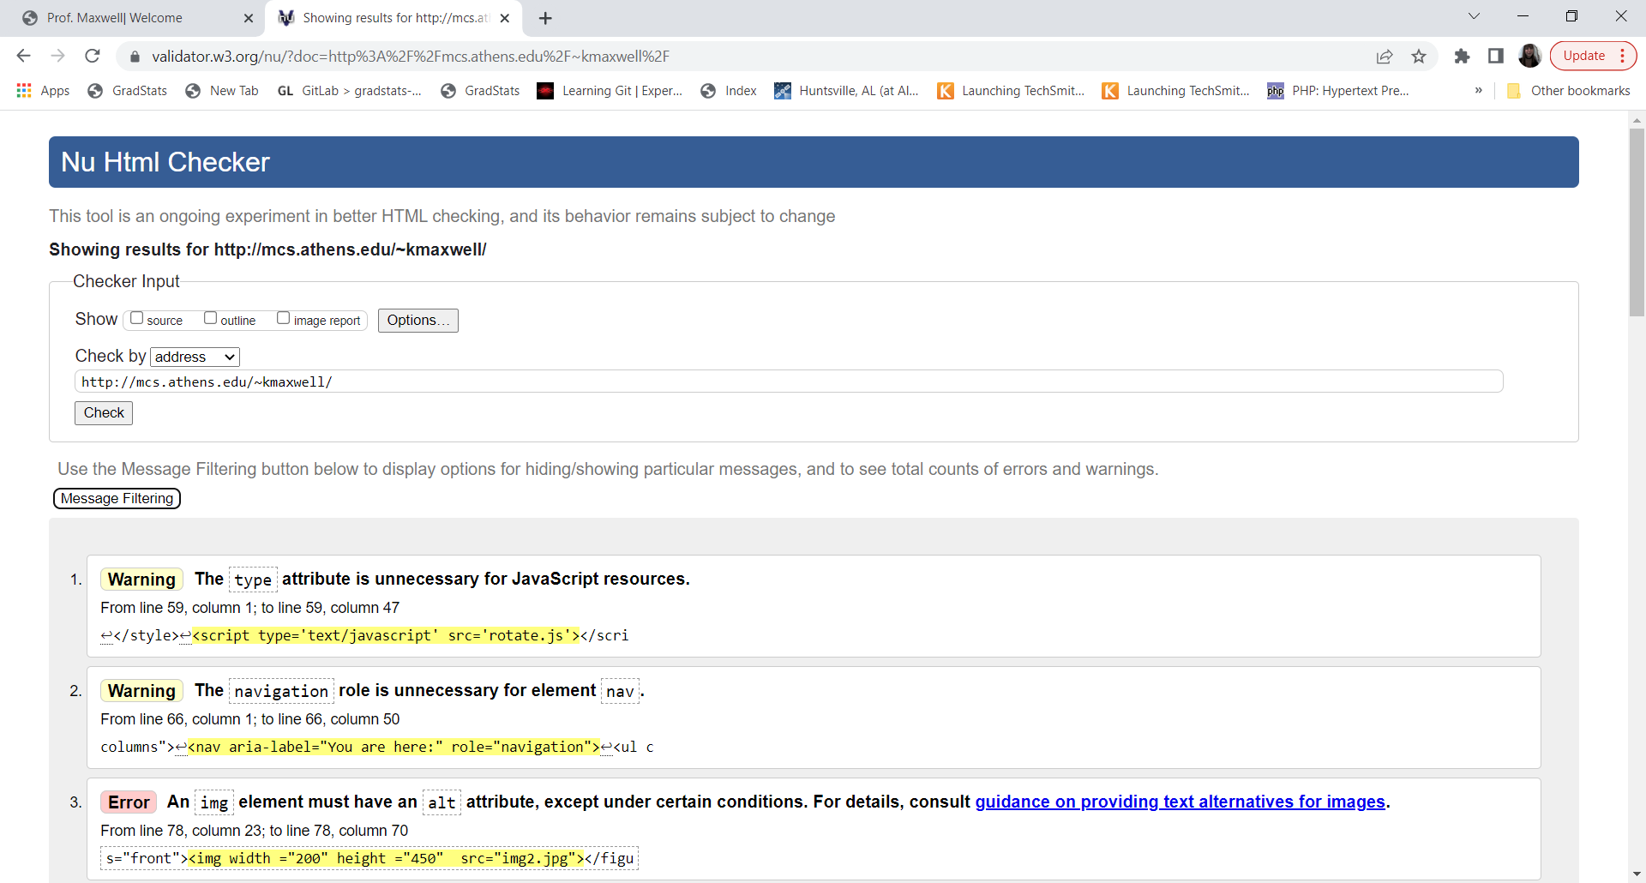

Figure Dr. Maxwell's HTML validation

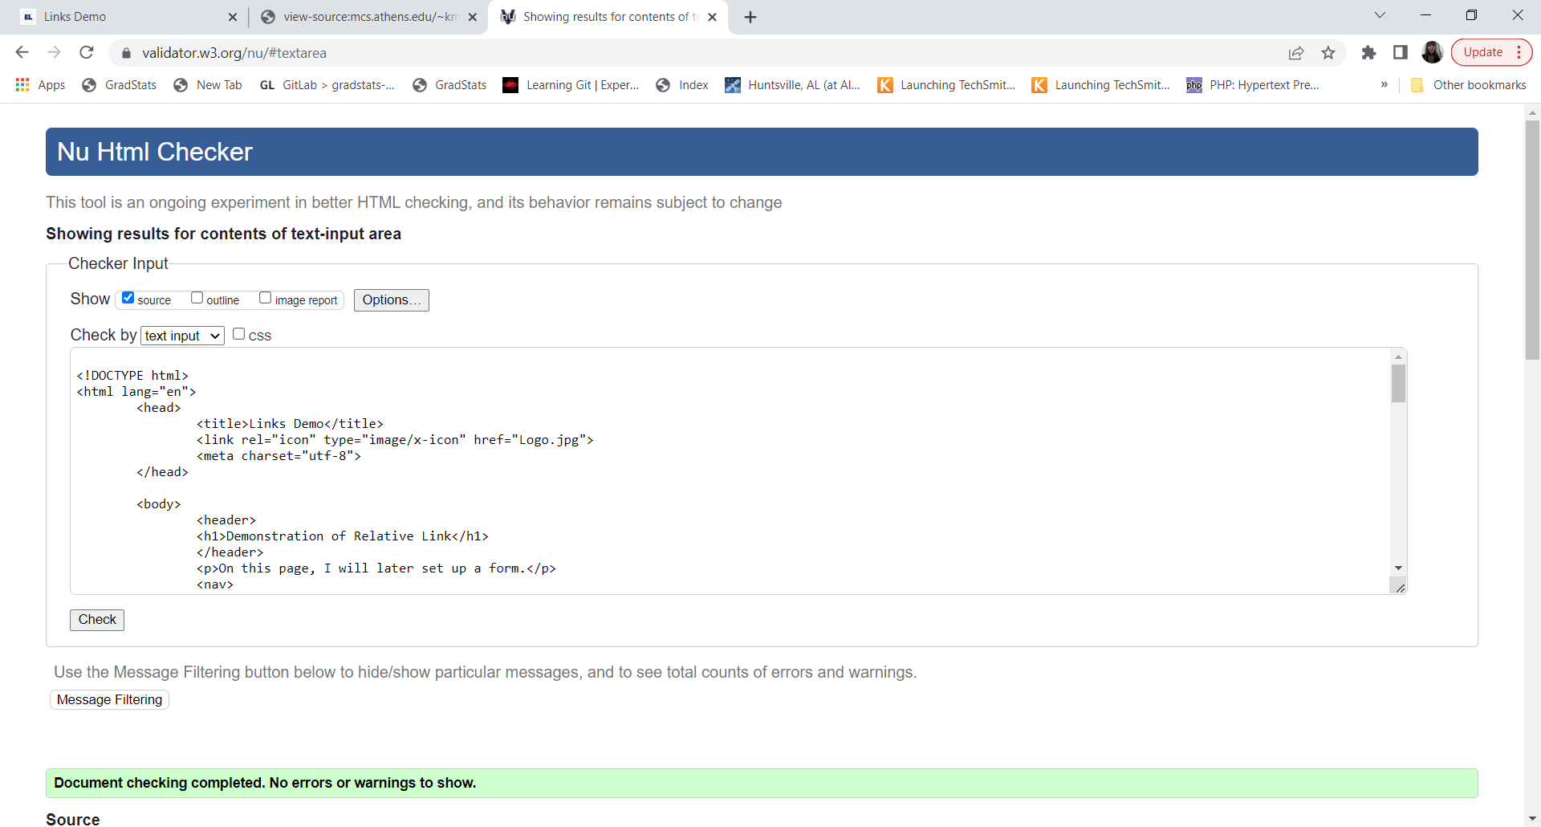

Figure Validated code from Direct input

Here is the link for you to validate your HTML code: <https://validator.w3.org/> You will need to create inline citations for when you discuss validations of your website on your report. Therefore, please be sure that you understand how to create those inline citations.

# **Accessibility**

Each page that you create for your website will need to have an accessibility statement with it. There are three different ways that your results may impact the write up in your technical document:

1. 100% Accessible

If your pages have no accessibility alerts, and they are all considered accessible. You may document that all of your pages are accessible but then you should document what you have done to make them this way.

1. Partially Accessible

Similar to #1 for the pages that are accessible you would discuss what you have done to make them this way, and for the pages that are not accessible you must be able to describe what the accessibility issue is and how it can be fixed in the future.

1. All of your pages have accessibility alerts

In this case you will need to explain what is causing your pages to have the accessibility alerts and how you can fix it in the future.

You are NOT required to fix the accessibility alerts, however you need to be able to document them and explain things in your own words using complete sentences. Do not just regurgitate the information that you receive from the WAVE analysis, that is not what we are looking for.

# **References**

1. “5 easy steps to creating a sitemap for a website,” *QuickSprout*, 07-Mar-2022. [Online]. Available: https://www.quicksprout.com/creating-website-sitemap/. [Accessed: 06-Jun-2022].
2. C. Neveu, M. Smith, and S. Last, “3.4 figures and tables,” *Technical Writing Essentials*, 01-Jan-2019. [Online]. Available: https://pressbooks.bccampus.ca/technicalwriting/chapter/figurestables/. [Accessed: 06-Jun-2022].
3. “Fridays after five,” *Athens Main Street*, 31-May-2022. [Online]. Available: https://athensmainstreet.org/fridays-after-five/. [Accessed: 06-Jun-2022].
4. “Ghost stories: Athens haunts walk returns for 12th Year,” *Editor's Pick - For the News Courier*, 26-Sep-2018. [Online]. Available: https://www.enewscourier.com/news/lifestyles/ghost-stories-athens-haunts-walk-returns-for-12th-year/article_bf5920b8-c108-11e8-bff6-a74eb389bc6d.html. [Accessed: 06-Jun-2022].
5. H. Bhasin, “What is the purpose of a website?,” *Marketing91*, 29-Jul-2018. [Online]. Available: https://www.marketing91.com/purpose-of-a-website/. [Accessed: 06-Jun-2022].
6. “IEEE - referencing guide: Citing in the text,” *Help and Support*. [Online]. Available: https://libguides.murdoch.edu.au/ieee/text. [Accessed: 06-Jun-2022].
7. K. LaGreca, “How to identify stakeholders for your website project,” *NP Group*, 14-Jan-2016. [Online]. Available: https://www.npgroup.net/blog/how-to-identify-stakeholders-for-your-website-project/. [Accessed: 06-Jun-2022].
8. M. Keenan, “What is meta description and how to write one (+examples),” *Shopify*, 10-Dec-2021. [Online]. Available: https://www.shopify.com/blog/how-to-write-meta-descriptions. [Accessed: 06-Jun-2022].
9. “Markup validation service,” *The W3C Markup Validation Service*. [Online]. Available: https://validator.w3.org/. [Accessed: 06-Jun-2022].
10. R. Allabarton, “The Definitive Guide: How To Make Your First Wireframe,” *6 steps to make your first wireframe [how to guide + video]*, 06-Aug-2021. [Online]. Available: https://careerfoundry.com/en/blog/ux-design/how-to-create-your-first-wireframe/. [Accessed: 06-Jun-2022].
11. “Sitemap Online Generator,” *Create your Google Sitemap Online - XML Sitemaps Generator*. [Online]. Available: https://www.xml-sitemaps.com/. [Accessed: 06-Jun-2022].
12. W. A. F. F. 48 D. Staff, “Is Athens State haunted by 'die-hard' alumni?,” *WAFF News Investigates*, 25-Oct-2013. [Online]. Available: https://www.waff.com/story/23784658/is-athens-state-haunted-by-die-hard-alumni/. [Accessed: 06-Jun-2022].
13. W. R. Marks, C. Daly, and J. McLaughlin, “40th Annual Limestone Sheriff's Rodeo,” *Limestone Sheriff's Rodeo*. [Online]. Available: https://limestonesheriffrodeo.com/. [Accessed: 06-Jun-2022].
14. “The Wicked Easy Way to create a table of contents in word,” *LinkedIn*. [Online]. Available: https://www.linkedin.com/business/learning/blog/productivity-tips/the-wicked-easy-way-to-create-a-table-of-contents-in-word. [Accessed: 06-Jun-2022].